**Instruct1**

This is a test to see how well you can follow a series of numbers.

On the next screen you will see an example problem. Find a number in the answer row at the bottom that follows the last number in the row at the top.

Click on the answer you think is correct.

Please click the mouse to continue.

**Example1**

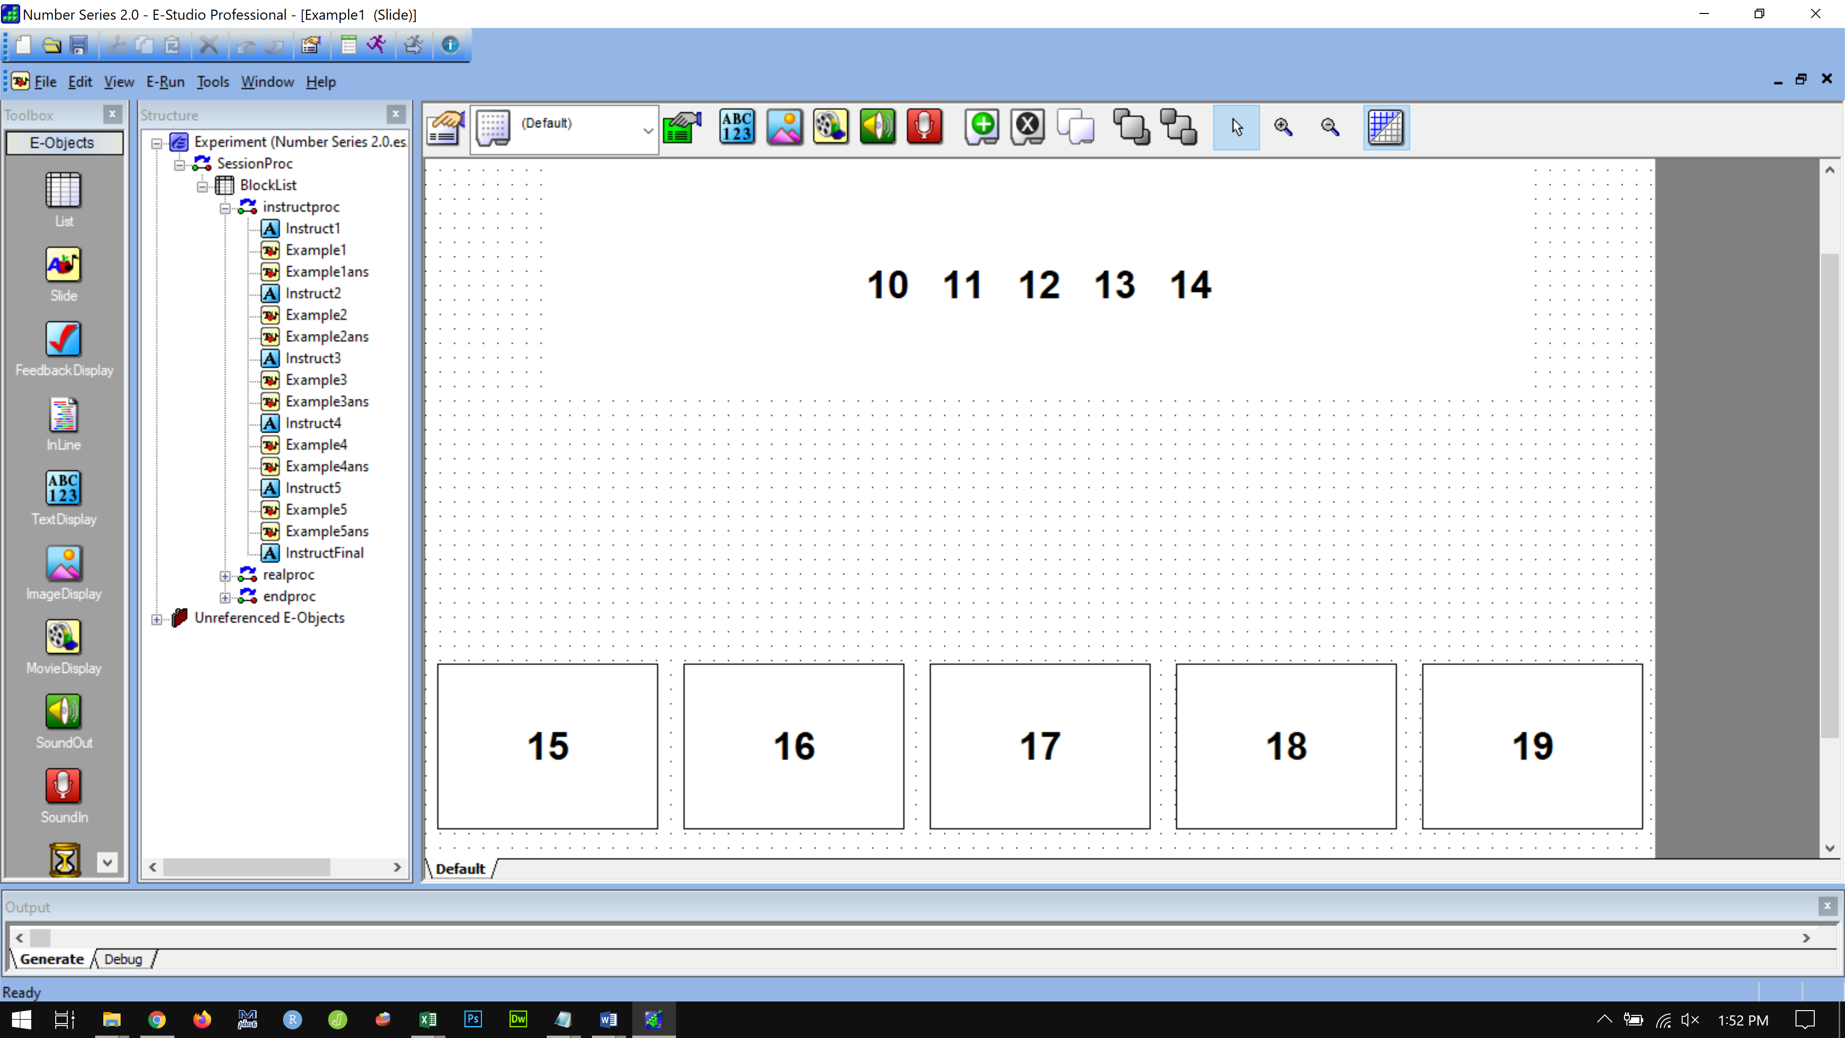

**Example1 ans**

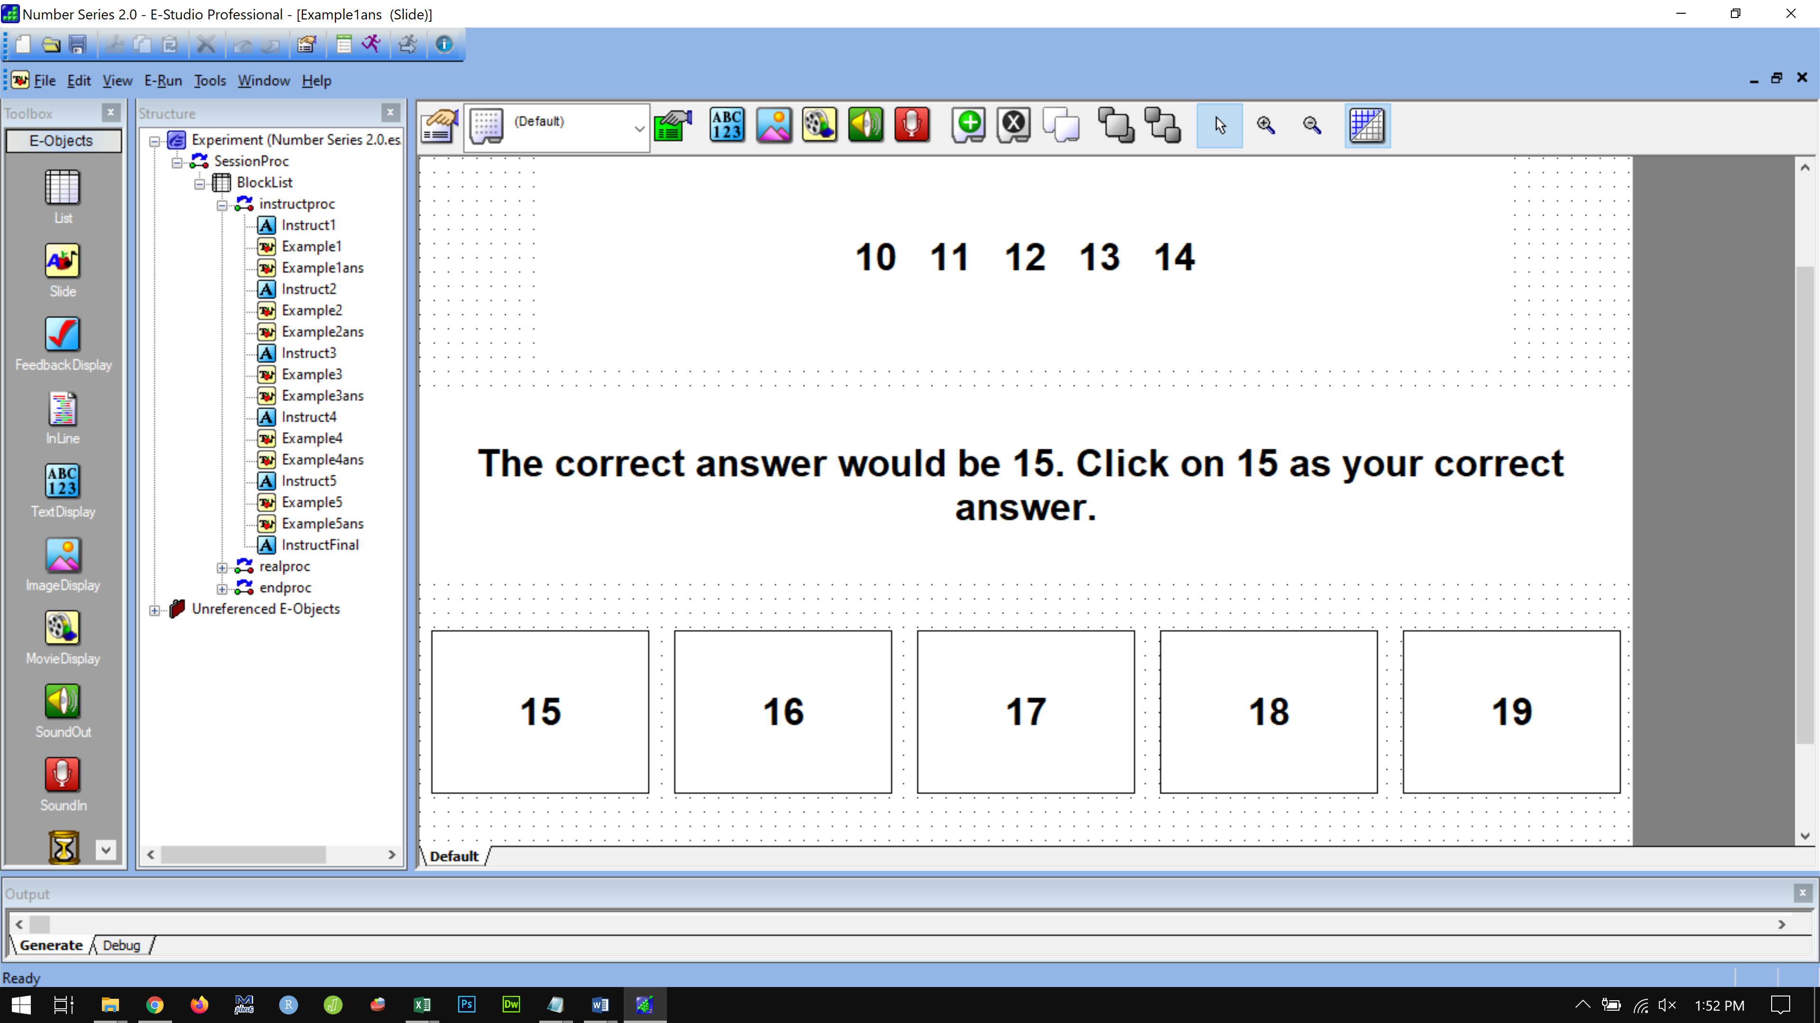

**Instruct2**

On the next screen is the second example.

Find the correct answer and click on it.

Please click the mouse to continue.

**Example2**

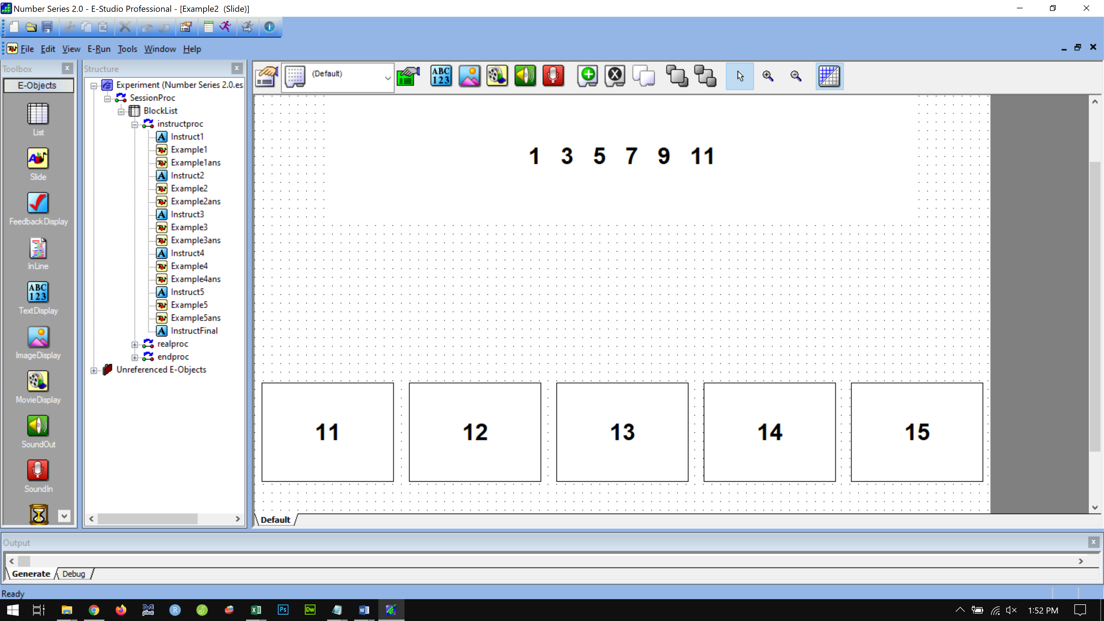

**Example2 ans**

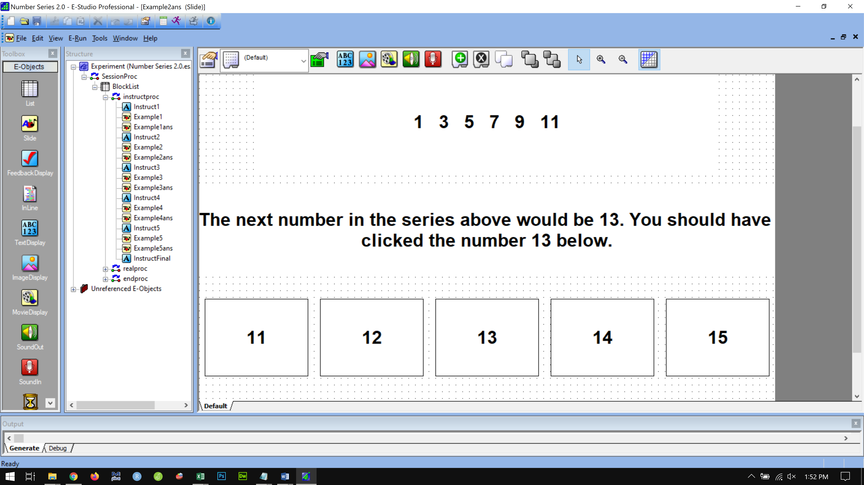

**Instruct3**

On the next screen is the third example.

Find the correct answer and click on it.

Please click the mouse to continue.

**Example 3**

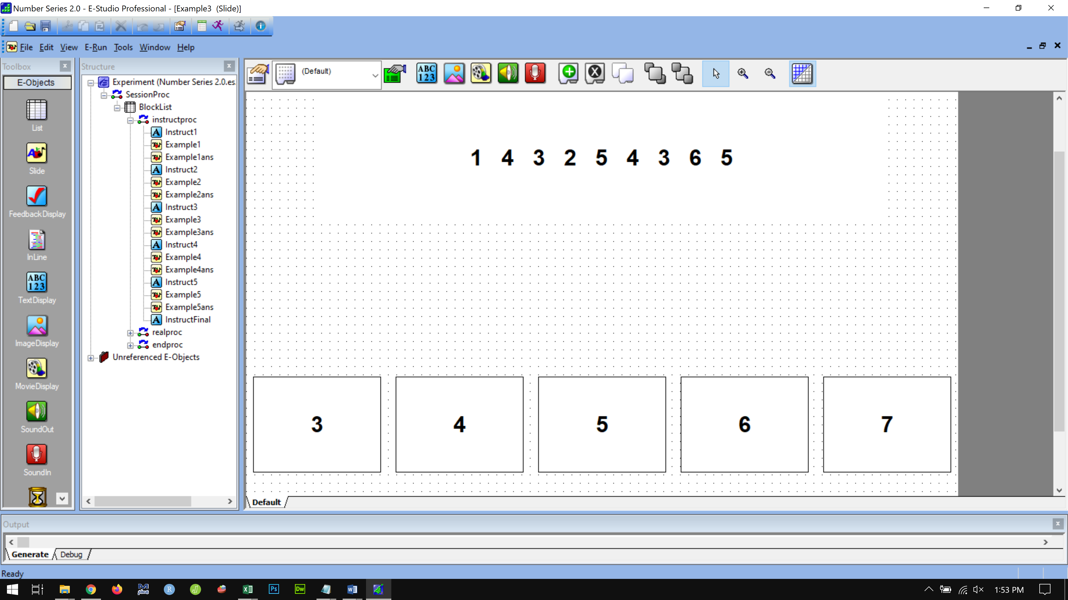

**Example 3 ans**

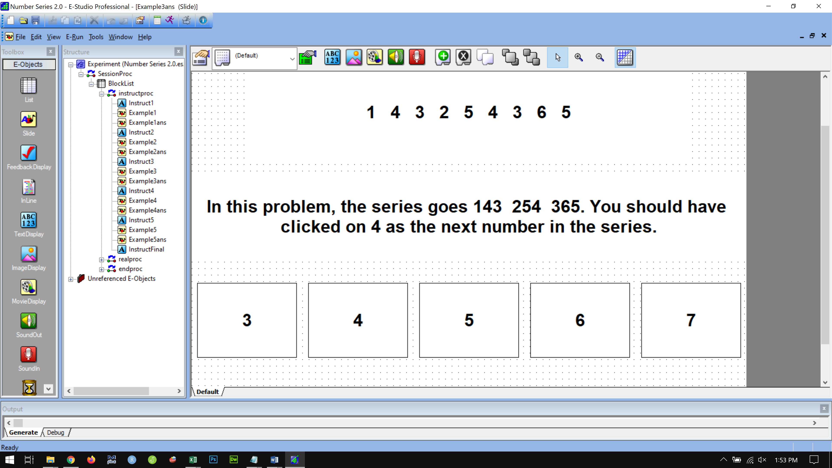

**Instruct4**

On the next screen is the fourth example.

Find the correct answer and click on it.

Please click the mouse to continue.

**Example4**

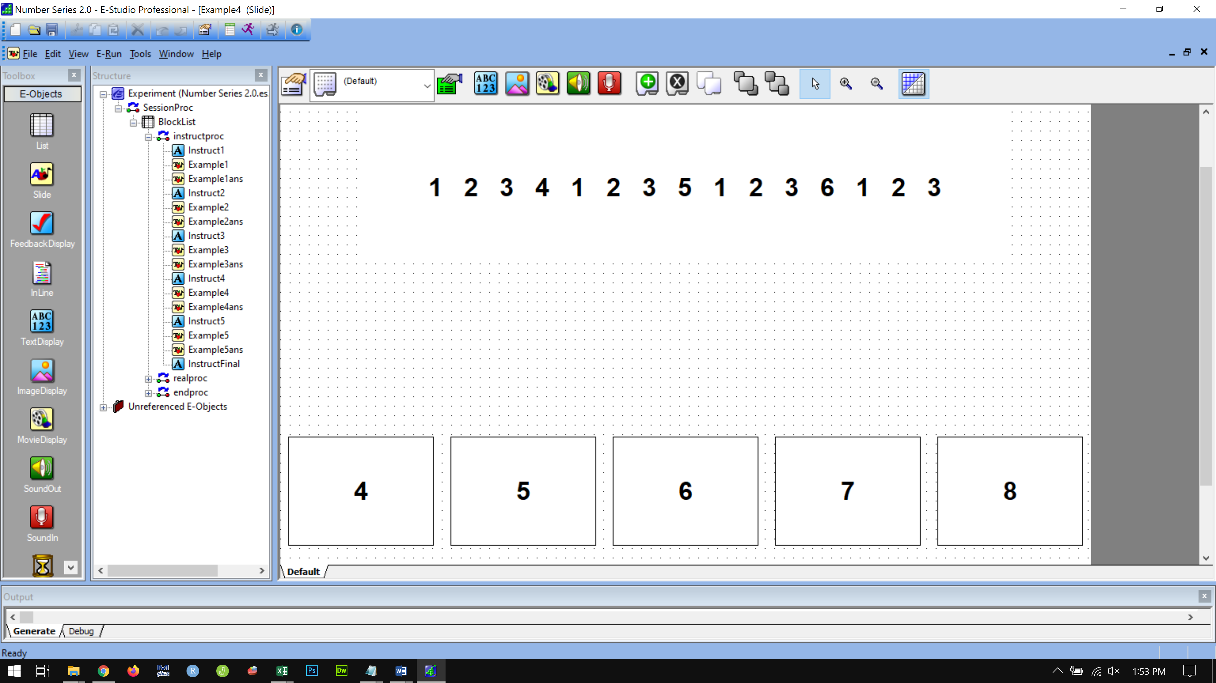

**Example 4 ans**

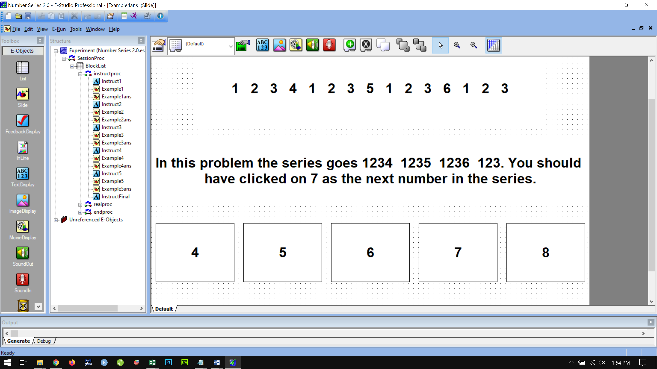

**Instruct5**

On the next screen is the final example.

Find the correct answer and click on it.

Please click the mouse to continue.

**Example5**

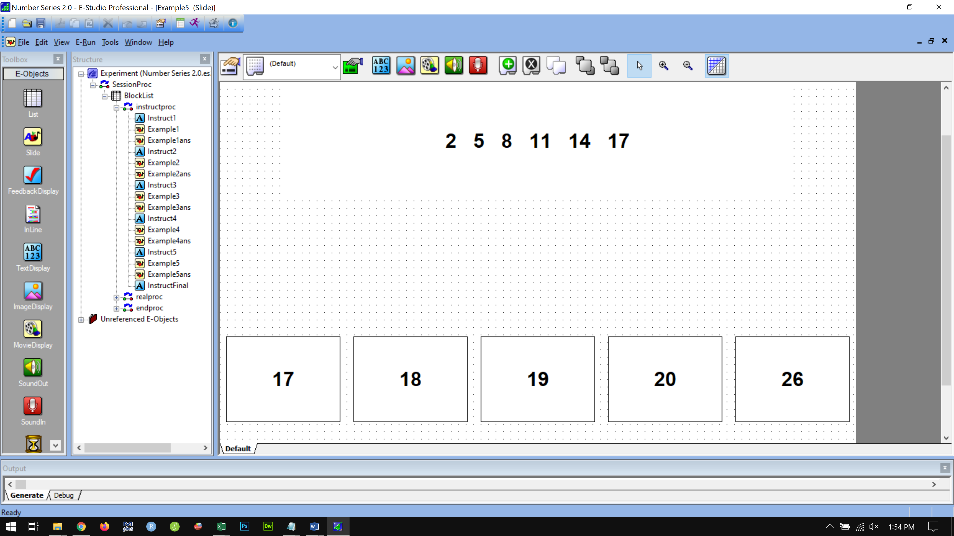

**Example5ans**

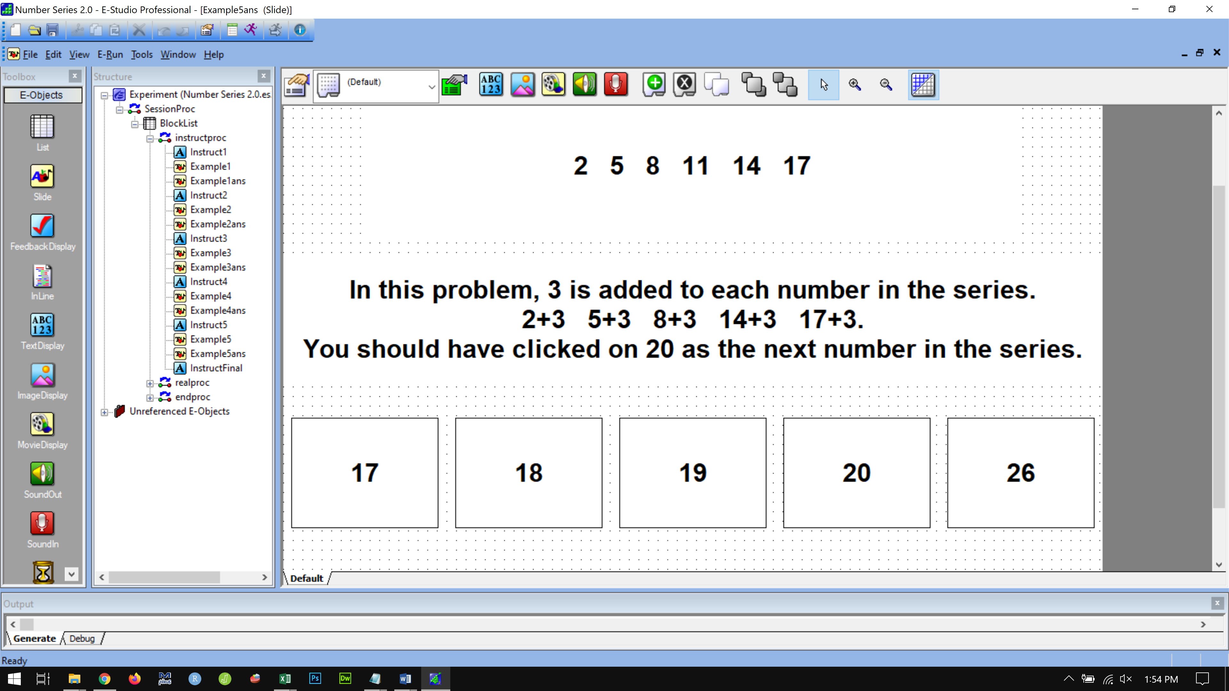

**Instruct6**

There are 15 problems in the experiment. You have 4 and a half minutes to complete the experiment.

You will find the problems in this set slowly get more difficult.

You may not finish all the problems in the set before the 4.5 minutes, so do as many as you can. The accuracy of your work matters most. Try your best to select the correct answer before moving on to the next problem.

Do you have any questions?

Press the SPACE bar to begin the real problems.